Answers and suggestions for Objective and subjective questions:

# I have made a new sheet names Updated Raw Data Sheet form the Raw Data Sheet. Also, one Objective Questions sheet as well.

A. Objective Questions:

1. What is the total no. of tables present in the data?

Ans- The total number of tables present in the data is 2 i.e. Raw data and Country description table.

1. What is the total no. of attributes present in the data?

Ans- There are total 2 tables so, Raw data table has 20 attributes and Country description table has 2 attributes.

1. How many categorical columns are there in the data? [Search about categorical and continuous data, and try to answer this question]

Ans- There are total 4 categorical columns – Cuisines, Currency (name), Country name, City name. I have selected only these as they have a discrete category. There are other categorical columns but the values or texts are not discrete or universal.

1. The data consists of some inconsistent and missing values so ensure that the data used for further analysis is cleaned.

Ans- In the Cuisines column there are 9 cells were empty so, I have manually entered the Cuisines names.

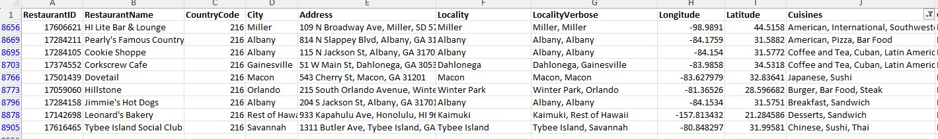

1. Using the Lookup functions, fill up the countries in the original data using the country code.

Ans- I have used VLOOKUP function for the same. For e.g. =VLOOKUP (C2,'country description’! $A$1: $B$16,2)

1. 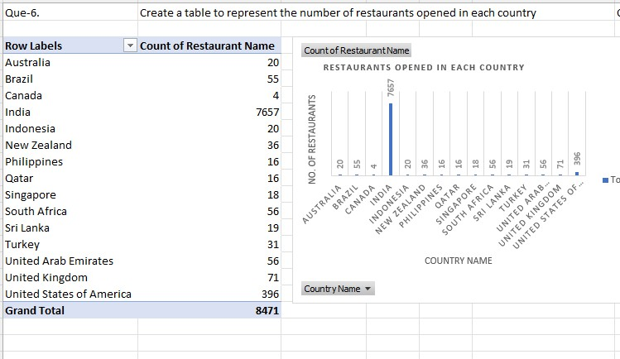Create a table to represent the number of restaurants opened in each country Ans-
2. Also, the management wants to look at the number of restaurants opened each year, so provide them with something here

Ans-

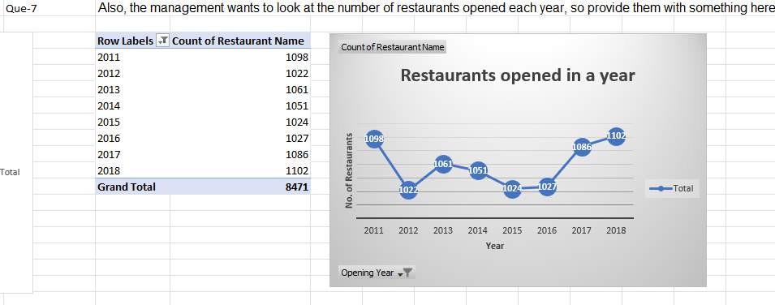

1. 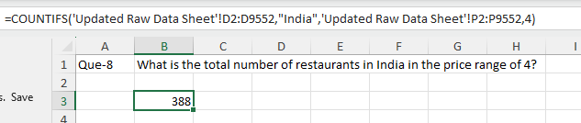What is the total number of restaurants in India in the price range of 4?

Ans-

1. What is the average number of voters for the restaurants in each country according to the data?

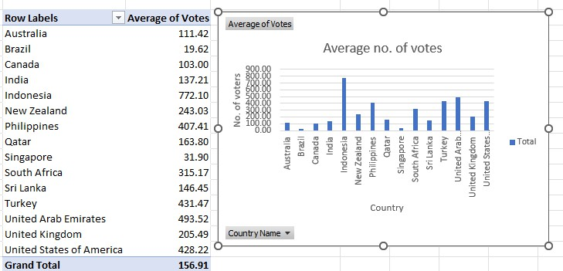

1. Calculate the average rating for all the restaurants that have price_range < 4 and provide online delivery. Use only the “IF” function, Logical Operators, and Aggregation functions to solve this problem. **[Note: Don’t use Conditional aggregation in this question.]**

Ans- I have created a Helper column in which I have used IF function with AND operator to find out the ratings for those who have price range<4 and provide online delivery. Ans then took the average of the entire column.

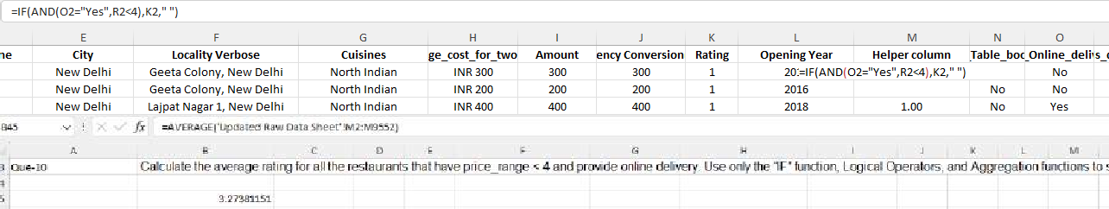

1. Using Conditional formatting highlight the rows of restaurants that are located in the countries or cities that you’ve suggested to the management for opening new restaurants.

Ans- I have put the conditional formatting for the text which contains the country

name as “Australia”,” Canada”,” Sri Lanka” and “Singapore”. This can be checked in

“Updated Raw Data Sheet”

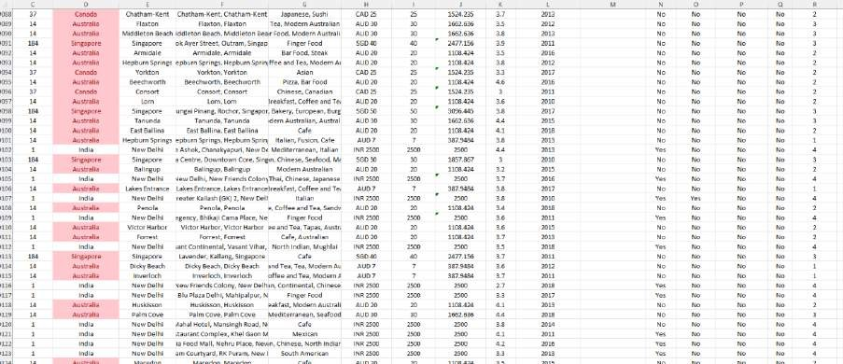

1. Create a new customized price column that consists of the abbreviation/symbol of the currency along with the Average_cost_for_two values. [Use string operations to do this task]

Ans- I have used this string operation > =CONCATENATE('Raw Data'!I2," ",'Raw Data'!P2)

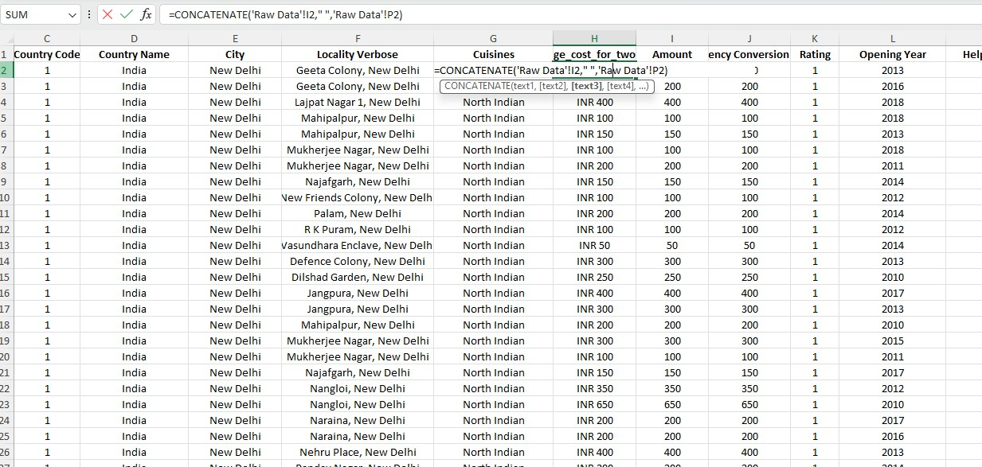

1. How can you create an array formula in Excel or Google Sheets to count the number of restaurants listed that do not offer online delivery, are in the lowest price range, and have an average cost for two people less than or equal to 250 Indian Rupees?

Ans- 1685



Subjective Questions-

1. Suggest a few countries where the team can open newer restaurants with lesser competition. Which visualization/technique will you use here to justify the suggestions?

Ans- Reference: Go through “SQ1-Country Suggestion” Worksheet detailed view.

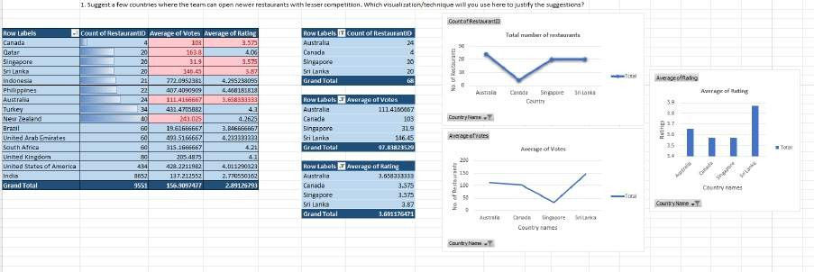

Approach: Considered Country name, Restaurant ID, Average of Ratings & Votes. Key Insights:

* 1. To check the number of restaurants opened in each country, the above Pivot table is made.
  2. In the Pivot table fields, rows have Country names and values have the average of votes and rating.
  3. I have sorted the above column in the ascending order to check the less no. of restaurants opened in a particular country. So, the countries with lesser Restaurants in the past 8 years are Canada, Qatar, Singapore, Sri Lanka, Indonesia, Australia, Turkey and New Zealand.
  4. For collaborative analysis, I will take the average of both the Average of votes and rating.
  5. The Average of Average of votes is 267, so I will firstly choose the Countries which have an Average of votes less than 267. Out of those countries mentioned in point 3, we will select Canada, Qatar, Singapore, Sri Lanka, Australia and New Zealand.
  6. Now, out of these 6 countries we can again make a better choice by checking the Average of Average of Rating which is 3.94. We will select the countries less than 3.94.
  7. My final choice of countries are Canada, Singapore, Sri Lanka and Australia.

1. According to the countries you suggested, what is the current quality regarding ratings for restaurants that are open there?

Ans- Reference: Go through “SQ2-State-City Suggestion” Worksheet detailed view.

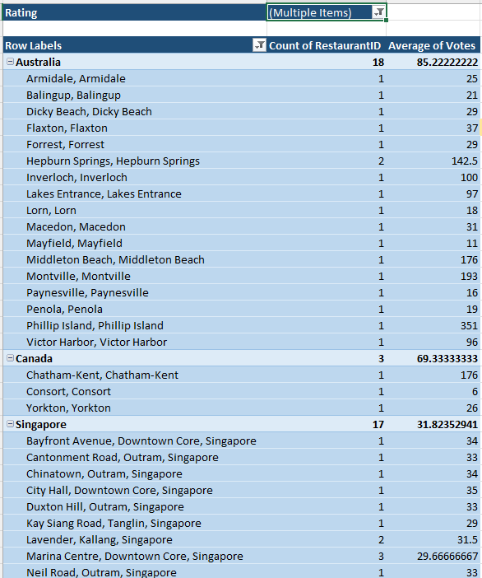

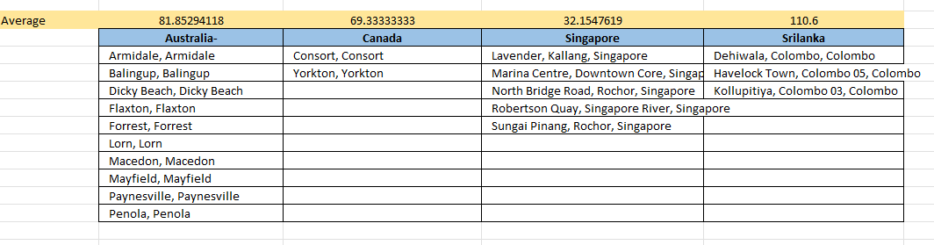

Approach: Considered Country name for those 4 suggested countries. Also, Average of Votes and Ratings in the filter section of Pivot field by selecting it to 1-2,2-3 & 3-4

Key Insights:

1. I created a Pivot table consisting of the 4 Countries which I selected - Australia, Canada, Singapore, Sri Lanka and Locality Verbose in the Rows.
2. The Count of Restaurants & Sum of Votes in Values and Average of Rating as Filter for Less than 4. In addition to that average vote more than the average votes for a particular country
3. So, out of these I will select all the Cities/States with Restaurant count 1 with greater votes.
4. Also, what is the current expenditure on food in the suggested countries, so we can keep our financial expenditure in control?

Ans- Reference: Go through “SQ3-Ratings Analysis” Worksheet detailed view

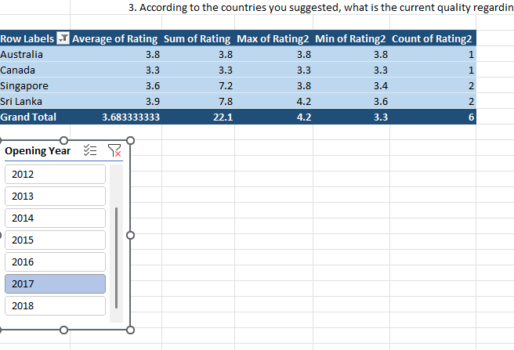

Approach: Considered Country name, Average, sum, min, max & count of Ratings.

Key Insights:

1. I have taken the Average, sum, max, min and count of Ratings for all the years to get an overall idea of it.
2. 2. As per the question, it is asking about the current quality of ratings hence I have introduced a Slicer with Opening Year.
3. I am checking the Ratings of year 2017 for all the countries and also it can be checked for other years as well. The average of rating for all the countries is either less than or equal to 3.9 so, Quality is average. The service needs improvement
4. Also, what is the current expenditure on food in the suggested countries, so we can keep our financial expenditure in control?

Ans- Reference: Go through “SQ4-Expenditure Analysis” Worksheet detailed view.

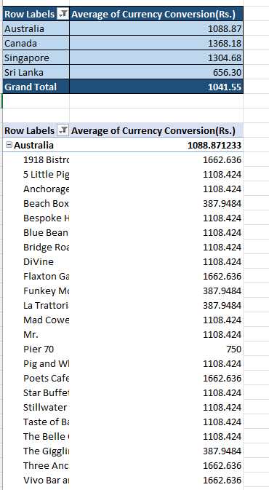

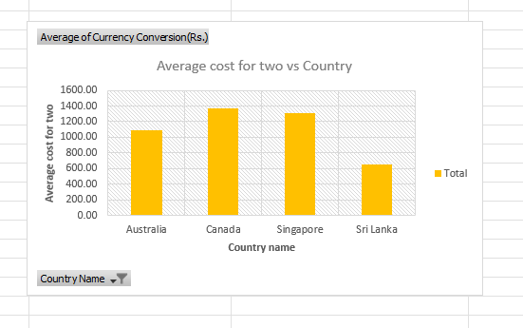

Approach: Considered Country names of the 4 countries and Average cost for 2 which is Currency Conversion (Rs.) in my table.

Key Insights:

1. I have taken the Average of Currency conversion which is in Rupees. So, the average for particular country in mentioned in the table.
2. Average for two persons is renamed by me as Currency conversion(Rs.) which is without the currency abbreviation for the easy analysis.
3. It's evident that the average for 2 people in all the countries is near the average of all the 4 countries average cost for 2.
4. Come up with the names of restaurants from the recommended states that are our biggest competitors and also those that are rated in the lower brackets, i.e. 1-2 or 2-3.

Ans- Reference: Go through “SQ5- Competitor Analysis” Worksheet detailed view.

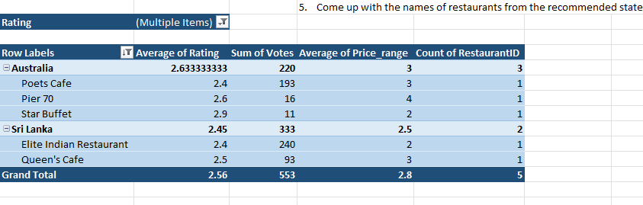

Approach: Considered All for Countries, put ratings in the filter section with 1-2 and 2-3 bracket.

Key Insights:

1. I have taken the Country name and Restaurant name is the row. Then the Count of Restaurants, Sum of Rating and Sum of Votes for the particular Restaurants.
2. To keep it specific for the Biggest Competitor, I am considering the higher number of votes which is for Poets Café of Australia and Elite Indian Restaurant of Srilanka.
3. Other two Countries don’t have any restaurant in that rating bracket.
4. Which cuisines should we focus on in the newer restaurants to get better feedback? Does the choice of cuisines affect the restaurant ratings?

Ans-Reference: Go through “SQ6- Cuisines Analysis” Worksheet detailed view.

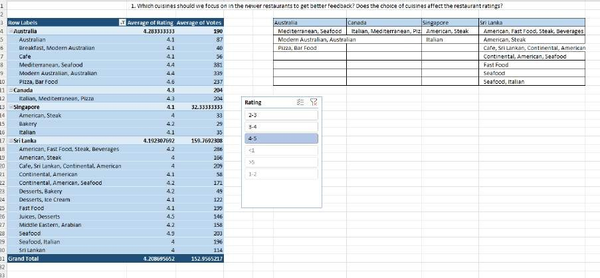

Approach: Considered Country names, Average of ratings and votes, Slicer for ratings.

Key Insights:

* 1. I formed this Pivot table and with the help of slicer selected rating as 4-5.
  2. Then I finalised those Cuisine whose average of average of all votes is greater than 190 for Australia, 204 for Canada,32.33 for Singapore and

159.76 for Sri Lanka.

1. According to our current data, should we go for online delivery and table booking? Does that affect the customer’s ratings?

Ans- Reference: Go through “SQ7-Table Booking” Worksheet detailed view.

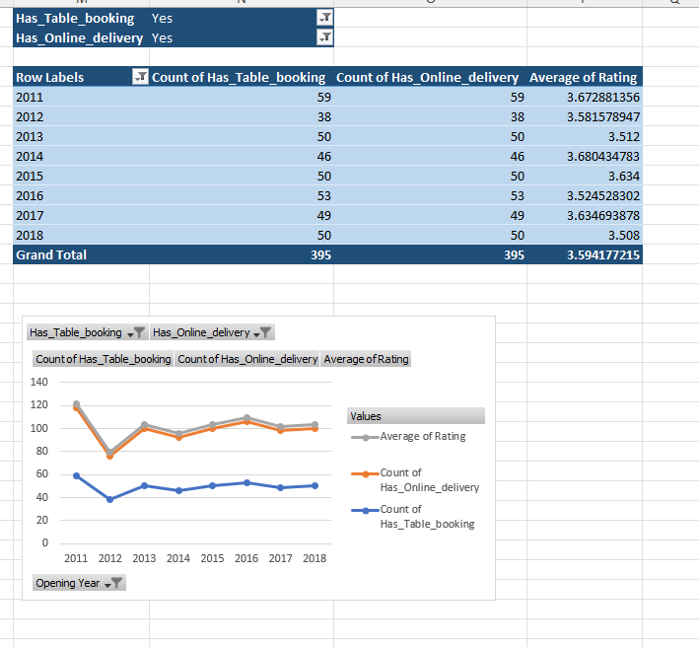

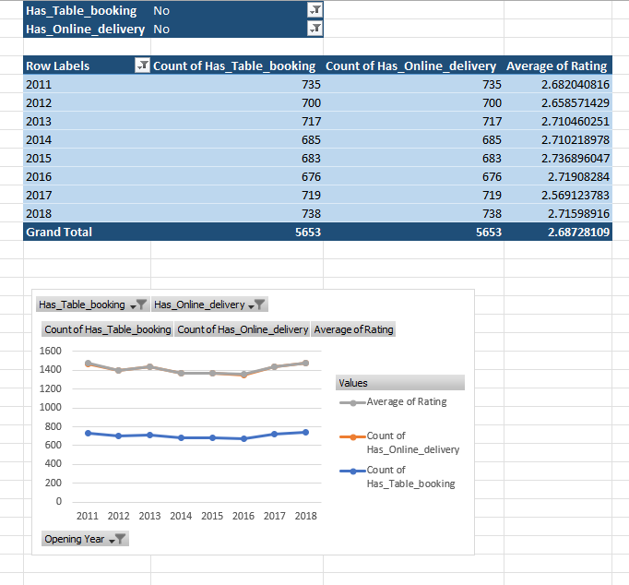

Approach: Considered Opening year, Count of Table Booking, Count of Online Delivery and Average of Rating

Key Insights:

1. According to the Pivot table and chart which is shown in the reference, Has Table Booking and Has Online delivery been set to yes, and we can see that the ratings are in the range of 3.5 -3.8.
2. But when Has Table Booking and Has Online delivery been set to no, and we can see that the ratings drop in the range to 2.6-2.7.
3. We can say that Yes, its affects the ratings when Table booking and Online delivery provision is not there.
4. Should the team keep the rate of cuisines higher? Will that affect the feedback? According to our data are the rates of cuisines and ratings, correlated?

Ans- Reference: Go through “SQ8- Correlation” Worksheet detailed view.

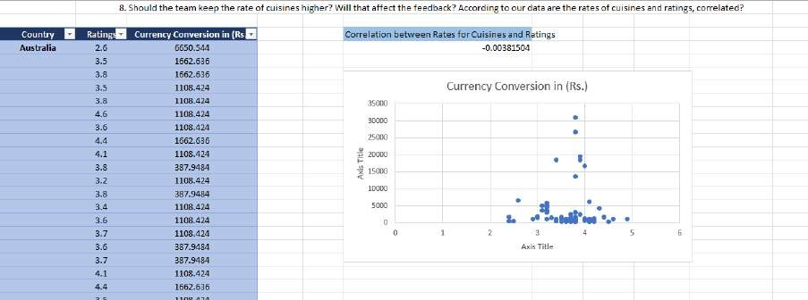

Approach: Considered those 4 countries, ratings and Average cost for two (Currency Conversion(Rs.)

Key Insights:

1. Applied the correlation function and the answer came to be -0.00381
2. There is an Inverse Correlation between the Rates for Cuisines & Ratings, if we increase the rate of cuisine the ratings will reduce and vice versa.
3. 3. But since the value is near to 0 the effect of ratings reduced is negligible meaning it is okay to increase the price of cuisines.
4. What is the distribution of the number of restaurants of different price ranges in all the countries?

Ans- Reference: Go through “SQ9-Distribution Analysis” Worksheet detailed view.

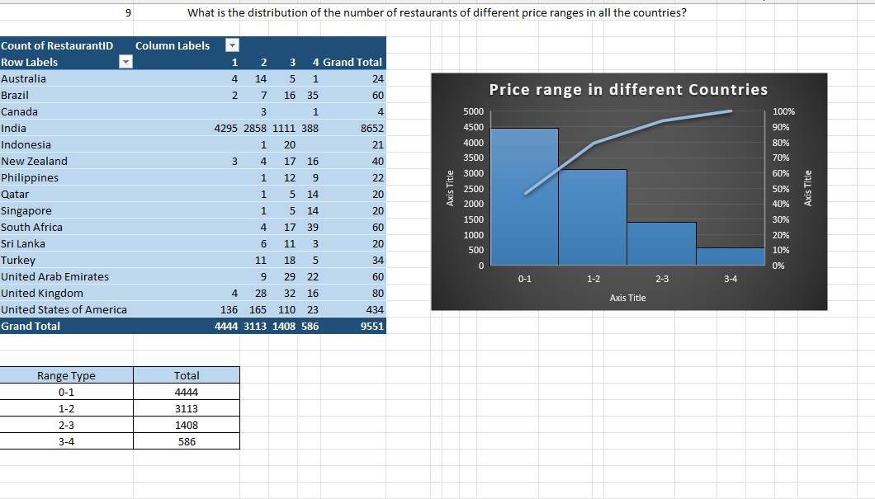

Approach: Considered all the countries, Ratings in the column field of the pivot table. Key Insights:

1. I formed a table where I grouped the range types and mentioned the total counties for that range.
2. Created a Histogram which shows the total number of the restaurants for a particular range type.
3. Explain your approach in brief for suggesting countries/cities in order to open new restaurants, if the objective and subjective questions would have not been given to assist you. **[you have to give bullet pointers in order to answer this question]**

# The dashboard must consist of Year-wise and country slicers.

Ans- Go through “SQ10-” Worksheet detailed view.

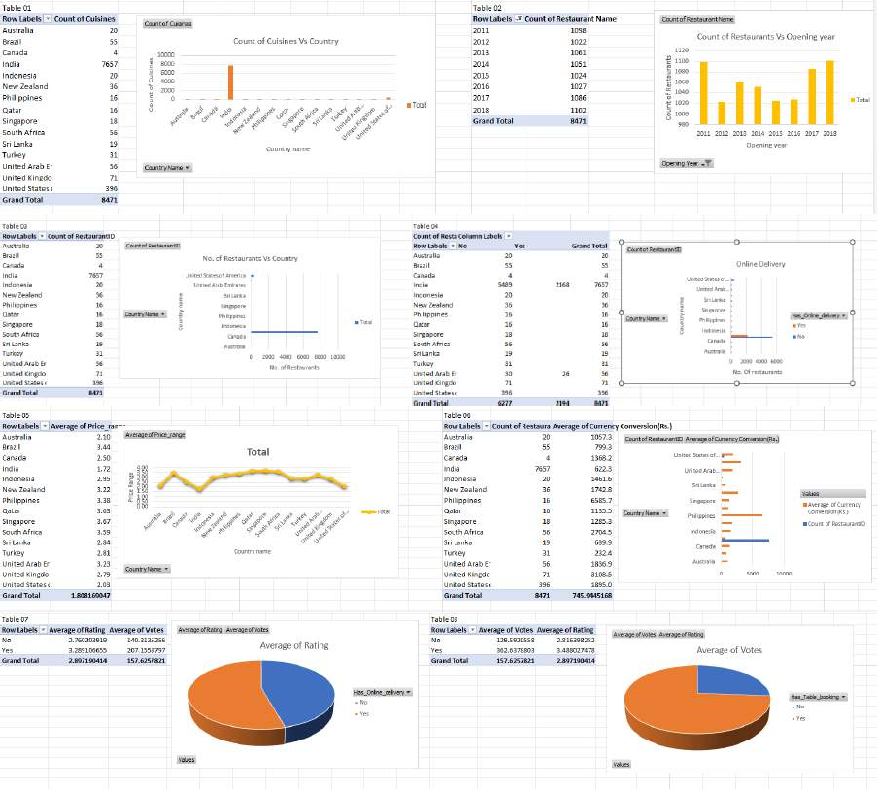01-

02-

03-

04-

1. I have created 8 Pivot charts and their respective tables to check the total number of restaurants opened in all the years and many others for other findings.
2. If the questions were not provided to us then I would create basic pivot charts for all the attributes present depending upon the Question statement which was to suggest newer restaurants to open in different Countries.
3. The main parameters here are the number of restaurants opened in a particular country.
4. This will give the Countries which has less restaurants.
5. After that I would have taken the average of votes and ratings and on basis I would have selected the Countries.
6. All the above Charts I would have made first to get the overall analysis of the data to start making decision.
7. And then my steps would be similar to what Subjective and Objective questions are asking us.